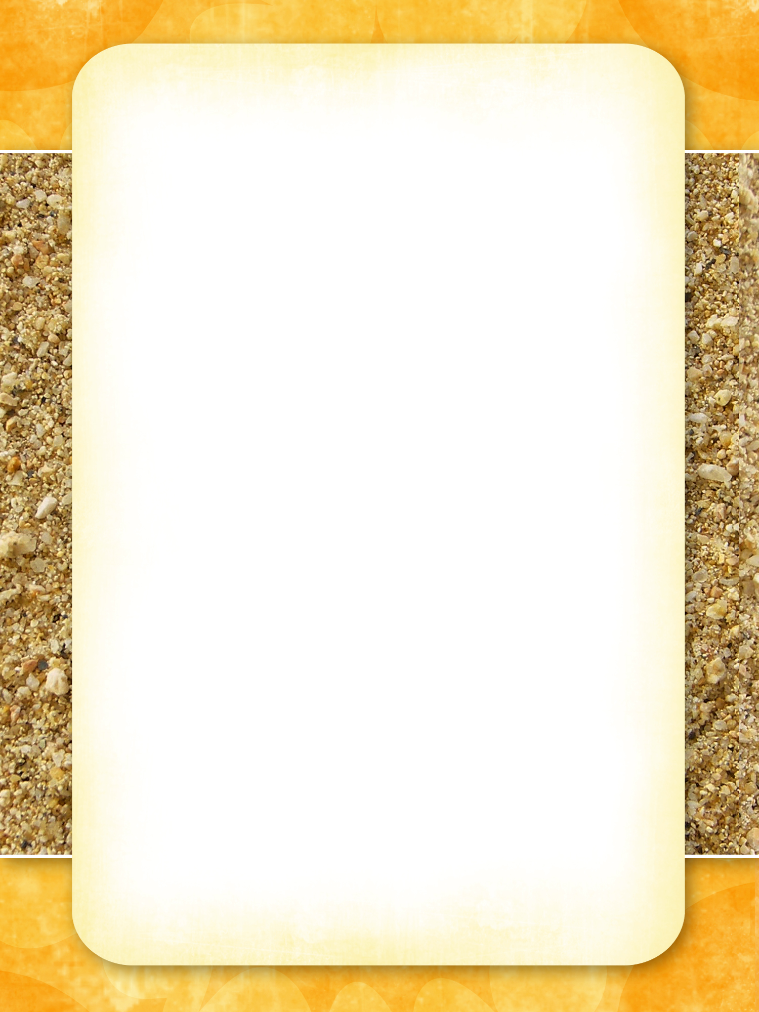

# Snack Menu

**Happy Hour Every Day 6-7pm - All Drinks 50% Off the Marked Price**

## Basket of Chips

* French Fries $5.00
* French Fries with Gravy $5.50
* Wedges with Chili Sauce & Sour Cream $6.00

## Seafood

* Calamari Rings with French Fries and Aloe Dressing $8.00
* Seafood Caesar Salad $10.00
* Fish and Chips $11.00
* Barramundi $22.00
* Creamy Garlic Prawns with Rice $22.00

## Meat

* Chicken Kiev $11.00
* Chicken Stir Fry with Vegetables $11.50
* BBQ Pork Ribs with French Fries $12.50
* Grilled Porterhouse Steak (250gms) with Mushroom Sauce $20.00
* Grilled T Bone Steak (250gms) with Dijon Mustard $21.00
* Fillet Steak (200gms) with Red Wine Sauce $25.00

## Side Dishes

* French Fries $5.00
* Stir Fry Vegetables $5.50
* Steamed Vegetables $5.50

**Desert**

* Ice Cream – Vanilla, Strawberry or Chocolate $7.00
* Chocolate Mud Cake with Cream $8.00
* Crème Brûlée $9.50